Title: ANALYTICAL METHOD VALIDATION PROTOCOL

OF Valnemulin HCl in Biovalinat

1. OBJECTIVE: To prove that the analytical method of Valnemulin HCl suitable for its intended use.
2. SCOPE: Analytical method of Valnemulin HCl.
3. RESPONSIBILITY:
Methodology section head is responsible for implementation of the protocol.
QC manager is responsible for reviewing and approval of the protocol and the final report.
DOCUMENTATION REQUIRED:
Analytical monograph
Equipment operation procedure.

REVALIDATION:
It is necessary in the following circumstances:
Changes in the composition of finished product.
Changes in the analytical procedure.
PROCEDURE:
System precision: System precision is conducted using 6 replicates of the standard solution.
System precision results
Determination Number |  | Observed Peak Response |  |  |  | Acceptance criteria
Determination # 1 |  |  | 3681.95068
Determination # 2 | 3681.28784
Determination # 3 | 3706.0415
Determination # 4 | 3717.49268
Determination # 5 | 3718.02954
Determination # 6 | 3714.43774
Mean: | 3703.206663
SD: | 17.26
RSD: |  |  | 0.47 |  | RSD ≤ 1.0%
Comment: the system is precise as the RSD is not more than 1%.
Linearity and Range: Experimental conduct: Linearity is performed by preparing at minimum 5 different concentrations of Valnemulin HCl standard using the method of determination of Valnemulin HCl in Biovalinat. Linearity is defined by the squared correlation coefficient, which should be ≥ 0.99, range covers from 50% to 200 % of the standard solution after dilution.
Linearity and range results
% of Working Concentration | Concentration (mg/ml) | Observed peak area (mean) | Acceptance criteria
50% | 266.25 | 1867.63281
80% | 426 | 2991.795775
100% | 532.5 | 3707.45786
160% | 852 | 5948.600585
200% | 1065 | 7437.43701
Slope: |  | 6.97
Intercept: |  | 10.87
r: |  | 0.99999 | 0.999

Comment: the method is linear as the correlation coefficient {r} is more than 0.999
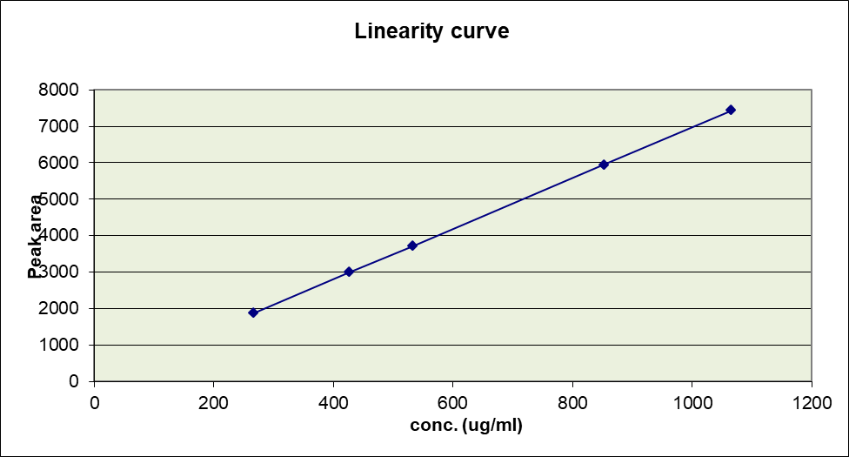

Linearity Equation
A measure of the strength of linear association between two variables. Correlation will always between -1.0 and +1.0. If the correlation is positive, we have a positive relationship. If it is negative, the relationship is negative.
Formula:
Correlation Co-efficient equation :
Correlation(r) =[ NΣXY - (ΣX)(ΣY) / Sqrt ([NΣX² - (ΣX)²][NΣY² - (ΣY)²])]
where
N = Number of values or elements
X = First Score
Y = Second Score
ΣXY = Sum of the product of first and Second Scores
ΣX = Sum of First Scores
ΣY = Sum of Second Scores
ΣX² = Sum of square First Scores
ΣY² = Sum of square Second Scores
Linearity Plot
Plot concentration (X – axis) versus mean response for each concentration (Y-axis).
Regression equation: Y = a + bX
Y = Peak area X = the concentration (mg/ml)
a = intercept b = slope
Correlation coefficient = r
Method Precision (Repeatability):
Method precision is conducted using 6 replicates of the test solution.
: Method Precision (repeatability) results
Determination Number |  | Observed Peak Response |  |  |  | Acceptance criteria
Determination # 1 |  |  | 3696.75879
Determination # 2 | 3714.05249
Determination # 3 | 3687.94336
Determination # 4 | 3701.55054
Determination # 5 | 3683.16943
Determination # 6 | 3705.36475
Mean: | 3698.139893
SD: | 12.70
RSD: |  |  | 0.34 |  | RSD ≤ 1.0%

Comment: the system is precise as the RSD is not more than 1%.
Accuracy and Recovery: Experimental conduct: Samples are spiked by adding known quantities of Valnemulin HCl standard to the placebo matrix containing all excipients of the product. Accuracy is assessed using nine determinations over three concentration levels covering the specified range (i.e. three concentrations and three replicates). The measurements are made at a concentration which is to be 100% of the target concentration, and at 80 % and 160 %.
Accuracy is measured as percentage recovery.
Accuracy and recovery results
Working Concentration (mg/ml) | Peak area | Found concentration (mg/ml) | % Recovery | Acceptance criteria
426mg/ml | 2995.58984 | 428.21 | 100.52 | 98-102%
426mg/ml | 3013.99658 | 430.85 | 101.14 | 98-102%
426mg/ml | 3011.94507 | 430.56 | 101.07 | 98-102%
532.5mg/ml | 3696.75879 | 528.81 | 99.31 | 98-102%
532.5mg/ml | 3714.05249 | 531.29 | 99.77 | 98-102%
532.5mg/ml | 3687.94336 | 527.54 | 99.07 | 98-102%
852mg/ml | 5991.23926 | 857.99 | 100.70 | 98-102%
852mg/ml | 5928.83691 | 849.04 | 99.65 | 98-102%
852mg/ml | 5937.39648 | 850.27 | 99.80 | 98-102%
Comment: the method is accurate as the percentage recovery is between 98-102%
Selectivity / specificity: Experimental conduct: Verification of selectivity is conducted by evaluating the Valnemulin HCl response in the presence of known concentrations of excipients.
Acceptance criteria: there is no interference and resolution factor between the peaks of drug in the test sample (material or product) and the peaks related to the excipients (product), or impurities (material or product) is NLT 1.5.
Selectivity / Specificity results
No. of replicates | Peak area of standard | Peak area of test | Acceptance criteria
Replicates # 1 | 3681.95068 | 3696.75879 | No interference, resolution factor between the sample peak and solvent peak is NLT 1.5
Replicates # 2 | 3681.28784 | 3714.05249
Replicates # 3 | 3706.0415 | 3687.94336
Replicates # 4 | 3717.49268 | 3701.55054
Replicates # 5 | 3718.02954 | 3683.16943
Replicates # 6 | 3714.43774 | 3705.36475
Average mean | 3703.206663 | 3698.139893
Comment: the method is selective as there is no interference between the Valnemulin HCl peak and excipients or solvent peaks. Resolution between the solvent peak and Valnemulin HCl peak is greater than 1.5.
Ruggedness: Experimental conduct: Ruggedness of the method is conducted by the analysis of the same samples under a variety of conditions, such as different analysts and different days, etc.
Day 2: 5 replicates of a single sample of Valnemulin HCl are implemented in the first day, and then on a second day, 6replicates of freshly prepared Valnemulin HCl is analyzed. The same analyst performs both tests.
Analyst 2: 6 replicates of a single sample of Valnemulin HCl is analyzed then the other person analyzes 6 replicates from the same sample prepared by him.
Column 2: 6 replicates of a single sample of Valnemulin HCl is analyzed in the first column then the same samples are analyzed in another column.
Mobile to mobile: 6 replicates of a single sample of Valnemulin HCl is analyzed by the first mobile phase then the same samples are analyzed by another mobile phase.
Change in flow rate: 6 replicates of a single sample of Valnemulin HCl is analyzed by the first flow then the same samples are analyzed by another flow.
Day-2 results
Replicate # | Set # 1 Results  (First day) | Set # 2 Results  (Second day) | Acceptance criteria
1 | 3681.95068 | 3747.18726
2 | 3681.28784 | 3701.42432
3 | 3706.0415 | 3666.72314
4 | 3717.49268 | 3930.22656
5 | 3718.02954 | 3798.56689
6 | 3714.43774 | 3708.49341
Pooled Mean | 3730.988463
Pooled SD | 71.45
Pooled RSD | 1.92 |  | ≤ 3%
Analyst-to-Analyst results
Replicate # | Set # 1 Results  (Analyst -1-) | Set # 2 Results  (Analyst -2-) | Acceptance criteria
1 | 3681.95068 | 3782.82739
2 | 3681.28784 | 3745.5603
3 | 3706.0415 | 3760.05884
4 | 3717.49268 | 3867.39844
5 | 3718.02954 | 3809.8252
6 | 3714.43774 | 3798.71973
Pooled mean | 3748.635823
Pooled SD | 56.84
Pooled RSD | 1.52 |  | ≤ 3%
Column to column results
Replicate # | Set # 1 Results  (column -1-) | Set # 2 Results  (Column -2-) | Acceptance criteria
1 | 3681.95068 | 3698.76514
2 | 3681.28784 | 3688.35474
3 | 3706.0415 | 3685.2605
4 | 3717.49268 | 3757.96631
5 | 3718.02954 | 3710.65137
6 | 3714.43774 | 3691.5144
Pooled mean | 3704.312703
Pooled SD | 21.80
Pooled RSD | 0.59 |  | ≤ 3%
Mobile to mobile results
Sample # | Set # 1 Results | Set # 2 Results | Set # 3 Results | Acceptance criteria
1 | 3697.42236 | 3681.95068 | 3766.42896
2 | 3851.12012 | 3681.28784 | 3738.2146
3 | 3905.00635 | 3706.0415 | 3717.13135
4 | 3817.93018 | 3717.49268 | 3713.42212
5 | 3804.98999 | 3718.02954 | 3723.62158
6 | 3785.052 | 3714.43774 | 3719.65015
Pooled mean | 3747.734986
Pooled STD | 61.77
Pooled RSD | 1.65 |  |  | ≤ 3%
Comment: the method is rugged as the RSD is not more than 3%.
Robustness: Experimental conduct: Robustness is determined by observing how a method stands up to slight variations in normal operating parameters. The analytical method is performed at different flow rates (+ 2%) provided that the other factors as mobile phase are kept constant.
Change in Flow rate results
Sample # | Set # 1 Results | Set # 2 Results | Set # 3 Results | Acceptance criteria
1 | 3803.74414 | 3681.95068 | 3861.3064
2 | 3811.98999 | 3681.28784 | 3875.38818
3 | 3825.70605 | 3706.0415 | 3865.30933
4 | 3842.00488 | 3717.49268 | 3886.72095
5 | 3841.77515 | 3718.02954 | 3874.34741
6 | 3879.24683 | 3714.43774 | 3904.28223
Pooled mean | 3805.058973
Pooled STD | 78.76
Pooled RSD | 2.07 |  |  | ≤ 3%
Comment: A slight change in flow rate is not critical parameter as the RSD is not more than 6%.
Auto sampler stability: Experimental conduct: Auto sampler stability is conducted by injecting 6 replicates of the same solution using the same auto sampler vial each at start of analysis.
Auto sampler stability results:
Determination number |  | Observed Peak area |  | Acceptance criteria
Zero time/replicate # 1 |  |  | 3681.95068
Zero time/replicate # 2 |  |  | 3681.28784
Zero time/replicate # 3 |  |  | 3706.0415
Zero time/replicate # 4 |  |  | 3717.49268
Zero time/replicate # 5 |  |  | 3718.02954
Zero time/replicate # 6 |  |  | 3714.43774
1 |  |  | 3795.60571
2 |  |  | 3722.87402
3 |  |  | 3752.32764
4 |  |  | 3721.98169
5 |  |  | 3723.67822
6 |  |  | 3715.22876
Pooled Mean: |  |  | 3720.911335
Pooled STD: |  |  | 30.12
Pooled %RSD: | 0.81 |  |  | 3%
Degradation Test for Valnemulin HCl by HPLC
I-Degradation with 1N NaOH (strong base): Quantitatively weight and transfer 532.5 mg Valnemulin HCl standard to a 100 ml volumetric flask. Add 30 ml of 1N NaOH and sonicate for 10 min. stand for 24 hours. Add 30ml of 1N HCl and complete to volume with water and sonicate for 10 min. Filter and reject the first 10 ml of the filtrate
Working standard solution: Transfer 5ml from stock standard solution to a 50ml volumetric flask and complete to volume with mobile phase
II-Degradation with 1N HCl (strong acid): Quantitatively weight and transfer 532.5 mg Valnemulin HCl standard to a 100 ml volumetric flask. Add 30 ml of 1N HCl and sonicate for 10 min. stand for 24 hours. Add 30 ml of 1N NaOH and complete to volume with water and sonicate for 10min.
Working standard solution: Transfer 5ml from stock standard solution to a 50ml volumetric flask and complete to volume with mobile phase
III-Degradation with Oxidation: Quantitatively weight and transfer 532.5 mg Valnemulin HCl standard to a 100 ml volumetric flask. Add 10 ml of H₂O₂ and sonicate for 10 min. Stand for 24 hours. Complete to volume with water and sonicate for 10min. Filter and reject the first 10 ml of the filtrate.
Working standard solution: Transfer 5ml from stock standard solution to a 50ml volumetric flask and complete to volume with mobile phase
Results
Test | Total Area for Active | Standard 100% area | % degradation | % Active
acid | 2838.30774 | 3703.206663 | 23.35% | 76.64%
Base | 2906.41101 | 3703.206663 | 21.51% | 78.48%
oxidation | 2938.4441 | 3703.206663 | 20.46% | 79.53%

